**DAILY ONLINE ACTIVITIES SUMMARY**

|  |  |  |  |  |  |  |  |  |
| --- | --- | --- | --- | --- | --- | --- | --- | --- |
| **Date:** | **21-07-2020** | | | | | **Name:** | **RAVALI P** | |
| **Sem & Sec** | **6TH SEM B SEC** | | | | | **USN:** | **4AL17CS076** | |
| **Online Test Summary** | | | | | | | | |
| **Subject** | | **-** | | | | | | |
| **Max. Marks** | | **-** | | **Score** | | | **-** | |
| **Certification Course Summary** | | | | | | | | |
| **Course** | **Python for data structures** | | | | | | | |
| **Certificate Provider** | | | **Coursera** | | **Duration** | | | **19 hrs** |
| **Coding Challenges** | | | | | | | | |
| **Problem Statement:Python Program for GCD of more than two (or array) numbers** | | | | | | | | |
| **Status: COMPLETED** | | | | | | | | |
| **Uploaded the report in Github** | | | | | **YES** | | | |
| **If yes Repository name** | | | | | <https://github.com/Ravalipr/Daily-Status.git> | | | |
| **Uploaded the report in slack** | | | | | **YES** | | | |

Online Test Details: -

Online Course Details:

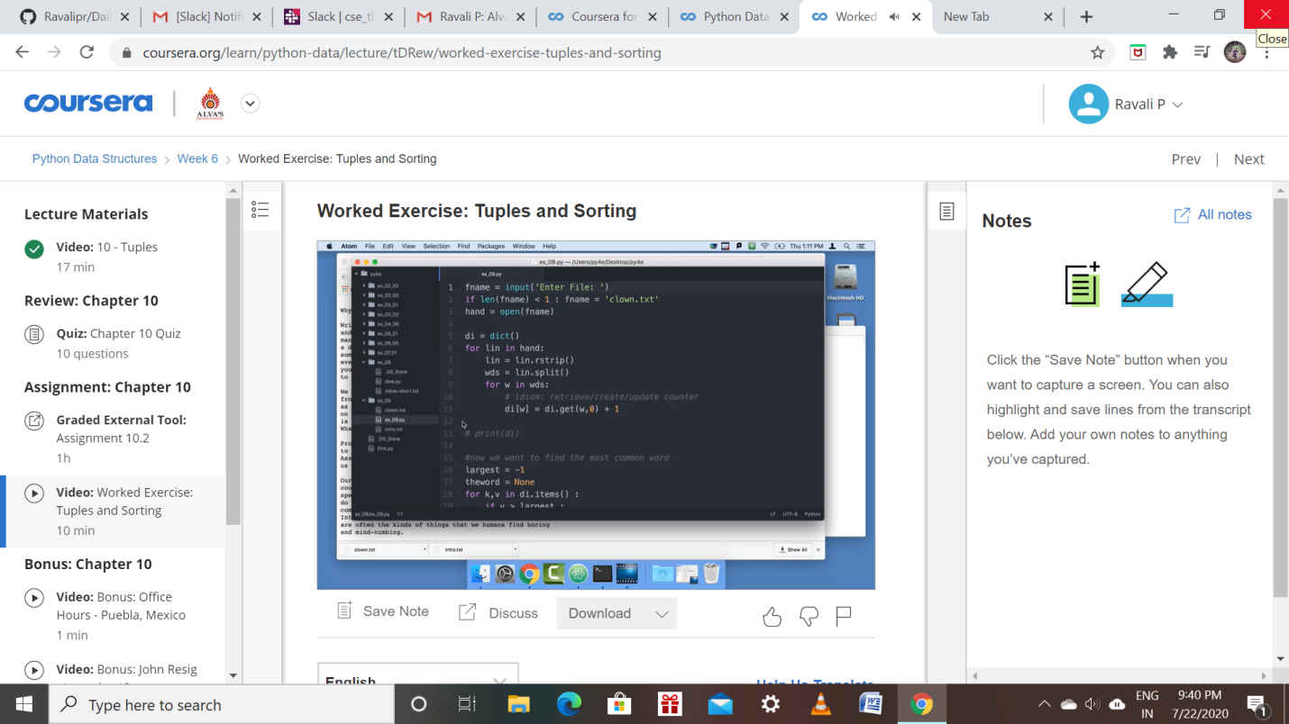

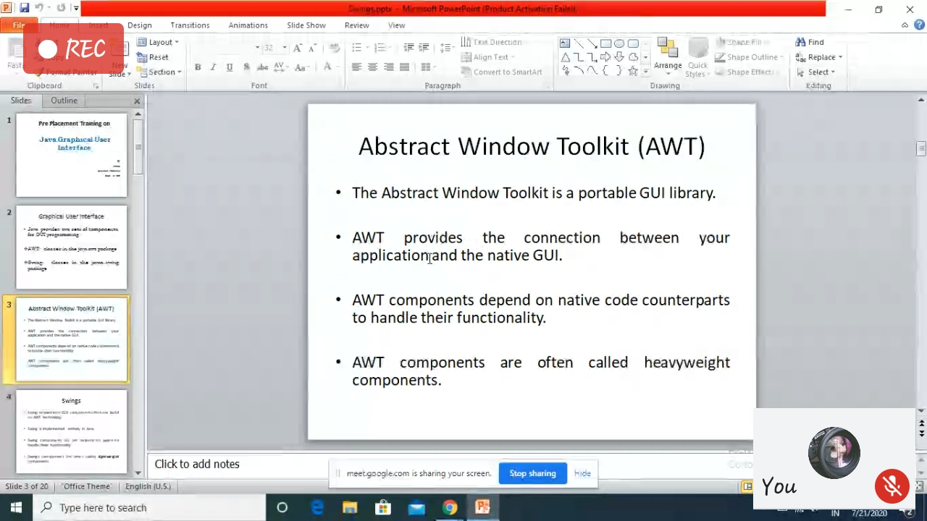

Attended the preplacement training on Advanced Java.

Online Coding Details:

